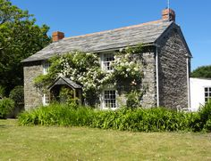
HESSELWOOD COTTAGE – HARLYN BAY
2023 BOOKING FORM

Title/Name:
Address 1:
Address 2:
Town:
County: |  | Postcode:
Telephone no: |  | Mobile:
Email:

Day of arrival (not before 4pm): |  | Day of departure (By 10am):
No. of adult guests: |  | Est. arrival time:
No of child guests: |  | Age of children:

How many people per room?: Superking __________ Twin 1 __________ Twin 2____________
Do you wish to bring a dog? (£35 per dog/per week) – please see booking conditions. | Yes |  | No | How many ______
Signed (I agree to ALL the booking conditions):
Date:
Total Tariff (including extras): |  | £
Deposit enclosed (50%): |  | £

50% of total fee required at time of booking, balance and damage waiver deposit due 4 weeks prior to holiday.
Please make cheques payable to Mr J Hellyar. Please enquire for Bank Transfer details if preferred.

PLEASE RETURN COMPLETED FORM/DEPOSIT TO:
MR J L HELLYAR, MORLEIGH, BIRTS STREET, BIRTSMORTON, WORCS, WR13 6AW

Should you require further information please contact Lisa Smith:
Tel: 01684 830070 / 07496 015489
Web: www.hesselwoodcottage.com
Email: hesselwoodcottage@hesselwoodcottage.com

